
Remote Control Unit (RCU) v2
Documentation
16-July-2011

Project Lead: Dan Unes
This is a working document to describe the RCU v2.

Purpose
The RCU v1 has gone through an initial prototype effort, but has been deemed not very ergonomically comfortable and lacking certain features that will make it more accessible by the FAST Robotics target communities. Unless otherwise noted, RCU will refer to RCU v2.

Description
The RCU will provide a User the ability to perform manual flight control, limited autonomous control via flight mode selections and provide audio/tactile/video feedback. The RCU communicates wirelessly to the ICARUS Vehicle and all other ICARUS Systems to different degrees. The RCU will also incorporate advanced functionality that the RCU v1 did not, providing a higher level of functionality.

Product Family
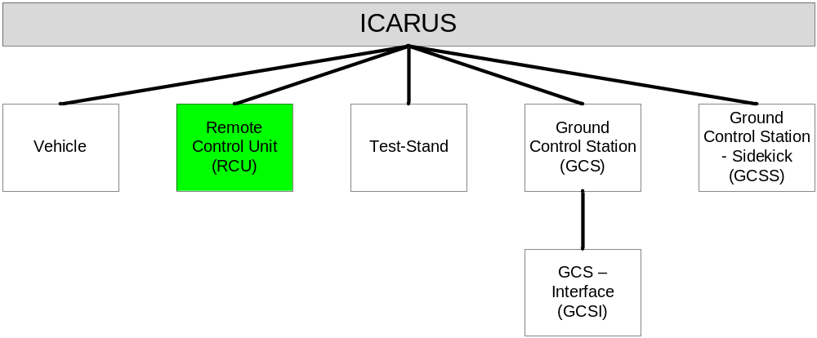

Capabilities
Defined by Marketing Manager, should completely encapsulate capabilities.

Capabilities
Manual Flight Control – Completely control all axis’s of Vehicle translation, rotation and tilt.
Limited Autonomous Control – Provide control for automatic Takeoff, Hover, Landing, transition to other Flight Modes such as Cruise and Advanced Hover.
User Update – Provide an easy way for Users to update firmware from manufacturer.
User Customization – Provide an easy User Interface to customize RCU Operation.
Extended Range – Provide several wireless communication methods to enhance the range of the ICARUS Vehicle.
Ergonomic – Provide User a comfortable and easy to use experience while using the RCU.
Video Feedback – Provide a video screen that is capable of giving User feedback on health, status and location.
Audio Feedback – Provide audio feedback to User wearable headphones

Engineering

Requirements
Defined by Lead Engineer, should completely encapsulate requirements.

Requirement | Target | Goal
Run-time | 5.1 Hours | 7.8 Hours
Weight | 1.25 lbs | 1 lbs
Prototype Cost | $1,000 | $750
Production Cost | $250 | $200
Communication Capability | XBee, Cellular | XBee, Cellular, WiFi
User Control | 2 2-axis Analog Thumbsticks, 6 Buttons | 2 2-axis Analog Thumbsticks, 4 Buttons, Touchscreen, 2 Analog Triggers
User Feedback | LED Bargraph, LCD Screen, Force Feedback | Video Display (Cel Phone), Force Feedback
Sensors | GPS | GPS, INU
Standby Time | 15 Hours | 15 Hours
User Customization | GUI
Communication Protocol | ICARUS Protocol

Run-time
Average length of time that RCU will be able to provide normal functionality with normal usage. Calculated based on RCU v1 Run Time * 1.5 (Goal is RCU v1 Run Time * 2).

Weight
Weight of RCU with all options/accessories/batteries installed. Calculated based on Xbox 360 Wireless Controller * 2 (Goal is based on Xbox 360 Wireless Controller * 1.5).

Prototype Cost
Cost of all components used in development PLUS all outsourced labor (machining, fabrication, etc). Based on RCU Prototype cost * 2.

Production Cost
Cost of RCU as available to the public MINUS options, accessories, etc. Based on RCU Prototype cost / 2.

Communication Capability
RCU should be able to communicate wirelessly using several different methods, which each have their own advantages and disadvantages. Each wireless transceiver will require another transceiver and appropriate switching logic.

Communication Standard | Advantage | Disadvantage
XBee Network | -Medium Range (up to 1 mile) | -Data bandwidth limited to 115,200 kbps  -Requires LOS
Cellular Network | Long Range (Beyond LOS) | -Account authorization required  -Bandwidth/latency unknowns and not directly controllable.
Wifi | Hi Bandwidth | Low Range (+300 feet)

User Control
User able to effectively operate RCU with minimal training, similar to standard game system control layouts.

User Feedback
RCU provides minimum feedback functionality similar to RCU v1. Goal is to integrate a Cel phone (also supports other Requirement Goals) to provide such advanced features as Google Earth integration, video display, etc.

Sensors
RCU should be able to at least acquire location information and ideally also collect inertial sensor data for the purpose of providing tilt control on RCU. This will extend the functionality of the RCU by potentially providing an easy method for tilt control of the ICARUS Vehicle.

Standby Time
Average length of time that RCU will stay powered on when not being used. Calculated based on RCU v1 Standby Time * 1.5 (Goal is RCU v1 Standby Time * 2).

User Customization
User able to redefine button and joystick usage through GUI. GUI also able to provide firmware updates available from FAST Robotics to RCU. Provide data interface through standard USB cable that also can power RCU to provide longer operation time.

Communication Protocol
RCU completely follows ICARUS Communications Protocol.

Sub-Systems
Electrical Subsystem:
Lead: Mike Welling
Includes all input/output and control devices. Covers all internal energy storage, battery charging and external powering of RCU. Also covers motors and driving circuitry for force feedback.

Communication Subsystem:
Lead:
All communication devices, standards, protocols and transceivers used.

Mechanical Subsystem:
Lead: Alex Ouellet
Enclosure, PCB Design.

Control Subsystem:
Lead:
User input/feedback, RCU software, GUI update software.

Critical Issues
Advanced Communication using Cellular Network
Cellular network communicates requires access and authorization to use cel towers. Also, latency and bandwidth are unknowns that need to be answered.
-Research authorization options.
-Experimentally research latency/bandwidth impact.
-Customer may require specific cellular carrier option.

Video Screen Glare
Using a Video screen as a primary method for user feedback presents an issue when using in direct sunlight which may create screen glare, especially since the RCU will normally be used in the outdoor environment.
-Anti-glare product on screen
-High-contrast video on display

User Input/Feedback
RCU should be able to provide User an enhanced level of service in a sleek package.
-Use Android Cellular phone to provide a small package to meet RCU Requirement Targets.

Software Roadmap

Version | Description
1.0 | Manual Control: Pitch, Roll, Yaw, Throttle.  Semi-Auto Control: TAKEOFF, HOVER, LAND, HOME  Display: Basic Sensor Data
2.0 | Google Earth Integration  Advanced Hover
3.0 | RCU INU Integration

Authorizations
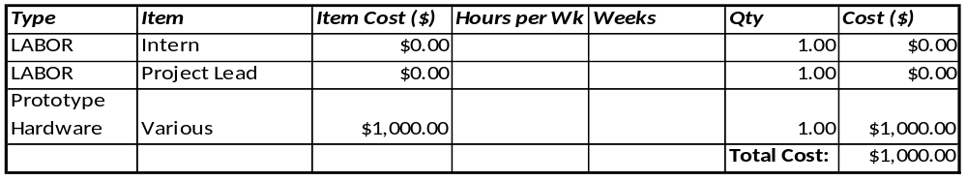

Timeframe
Start Work: July 1, 2011
Mechanical Design Finished: September 12, 2011
Electrical Design Finished: September 12, 2011
Software ver 1.0 Finished: September 1, 2011
Prototype Finished: November 1, 2011
Deliverables Finished: November 24, 2011

Team Organization
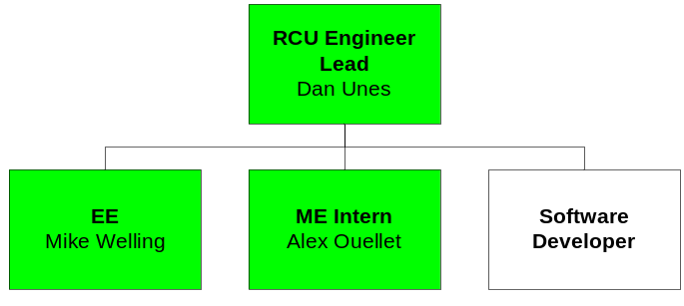

Collaboration
Dropbox: Dropbox\ICARUS\Remote Control Unit (RCU)\RCU v2\
Google Code: ICARUS\RemoteControl\RCU v2\Program\

Deliverables
User Manual
Bill of Materials
3D Design: Internal, External, PCB (if applicable)
2D Design: All relevant parts that will be fabricated
Electrical Schematic and PCB Design (if applicable)
Production Strategy
Source Code: RCU Firmware and GUI Software

Supporting Documentation
Component Selection:
Controller Pinout:
Electrical Design/Analysis:
ICARUS Communication Protocol Guide:
ICARUS Communication Protocol Specification:
RCU v1 Documentation: Dropbox\ICARUS\Remote Control Unit (RCU)\RCU v1\

